MATHEMATICS DEPARTMENT
Year 12 MATHEMATICS SPECIALIST
TEST 4: DIFFERENTIATION AND DIFFERENTIAL EQUATIONS
DATE: 28th June 2016 Name__________________________
Reading Time: 3 minutes
SECTION ONE: CALCULATOR FREE
TOTAL: 33 marks
EQUIPMENT: Pens, pencils, pencil sharpener, highlighter, eraser, ruler, SCSA formula sheet.
WORKING TIME: 30 minutes (maximum)
SECTION TWO: CALCULATOR ASSUMED
TOTAL: 25 marks
EQUIPMENT: Pens, pencils, pencil sharpener, highlighter, eraser, ruler, drawing instruments, templates, up to 3 Calculators,
1 A4 page of notes (one side only), SCSA formula sheet.
WORKING TIME: 20 minutes (minimum)
SECTION 1  Question | Marks available | Marks awarded | SECTION 2  Question | Marks available | Marks awarded
1 | 6 |  | 5 | 8
2 | 6 |  | 6 | 8
3 | 11 |  | 7 | 9
4 | 10
Total | 33 |  |  | 25

Section One: Calculator-free [33 marks]

This section has four (4) questions. Answer all questions. Write your answers in the spaces provided.

Question 1 [6 marks]

A first order differential equation is given by
(a) Use the equation to complete the table below. [2]
 | -2 | -1 | 0 | 1 | 2 | 3
 | 2 | 2 | 2 | 2 | 2 | 3

(b) Create a slope field on the 10 points on the graph below. [2]
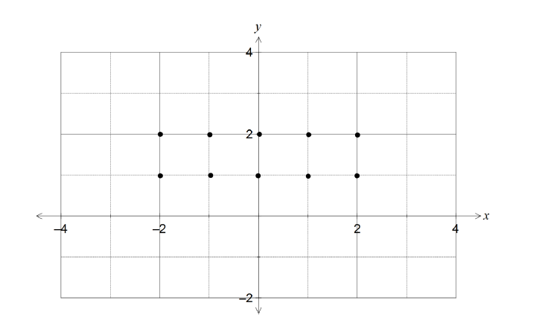
(c) Find the solution that passes through the point given by and . [2]

Question 2 [6 marks]

A function is defined parametrically by the equations and
(a) Find in terms of [2]

(b) By finding the second derivative, in terms of , show that there are no points of inflection on this curve. [4]

Question 3 [11 marks]
The equation of a curve in the plane is
(a) Show that for all points on the curve [4]

(b) Find the equation of the tangent to the curve at the point . [3]

(c) At what points on the curve is the tangent parallel to the y-axis? [4]

Question 4 [10 marks]

The volume V of blood flowing through an artery in unit time can be modelled by the formula where r is the radius of the artery and k is a constant.

(a) What is the effect on the volume of blood flow if the radius of the artery is halved?
[2]

(b) Use the incremental formula to estimate the percentage decrease in the radius of a
partially clogged artery that will produce a 10% decrease in the flow of blood. [5]

(c) Show that the incremental formula gives a physically absurd estimate for the change
in V resulting from a halving of the radius of the artery. Explain why this
estimate is so poor compared to the true answer found in (a). [3]

YEAR 12 MATHS SPECIALIST TEST 4 2016
NAME:________________________________________________
Section Two: Calculator-assumed [25 marks]
This section has three (3) questions. Answer all questions. Write your answers in the spaces provided

Question 5 [8 marks]

The needle in a sewing machine moves vertically with simple harmonic motion, and the distance between the highest and lowest positions of the tip is 8 mm.
The height of the tip of the needle above its mid-point position t seconds after it starts to move is x(t) mm, where x(t) satisfies the differential equation
(a) Determine x(t), given that the needle starts at its highest point. [3]

(b) How long does it take for the needle to return to its highest point? [2]

(c) How far does the tip travel in the first 0.3 seconds? [3]

Question 6 [8 marks]

A searchlight S is just above sea level and is revolving in the horizontal plane. The searchlight is located 15 metres out to sea from the nearest point N on a straight beach. S and N are in the same horizontal plane and the searchlight rotates at 2 revolutions per minute.
N
A
S (Searchlight)
15 m
Beach

Determine the rate at which the beam of light is moving along the beach when:
(a) the beam illuminates the beach at a point A such that the angle SAN is 30° [6]

(b) the beam illuminates at a point B on the beach 39 metres from S. [2]

Question 7 [9 marks]

The expected uptake of a new model of smart phone in a country, currently with one million models in use, can be modelled by the logistic equation , where is the total number of models in millions and is the time in weeks.

(a) Express as a function of in the form where and are positive
constants. [5]

(b) Calculate

(i) the expected number of models in use after 30 weeks. [1]

(ii) the week during which the number of models in use is increasing at the greatest rate. [3]

END OF QUESTIONS

